Study on The Activities of Teaching Gardens
to Reduce the Rate of Children Overweight and Obesity

Nguyen Bich Ngoc¹, Ngo Van Nhon², Duong Hoang Kiet³, Nguyen Thi Thao Minh⁴

¹Student, Ho Chi Minh City University Food Industry (HUFI),
140 Le Trong Tan Street, Tan Phu District, Ho Chi Minh City, Vietnam
E-mail: helennguyen1311@gmail.com
²Director, Institute for Quality Assessment and Development (IQAD),
37 Tran Quy Khoach Street, District 1, Ho Chi Minh City, Vietnam
E-mail: vqa.hcm@gmail.com, Telephone No: +84 - 903815243
³Dean of ISO Department, Ho Chi Minh City University Food Industry (HUFI),
140 Le Trong Tan Street, Tan Phu District, Ho Chi Minh City, Vietnam
E-mail: kiettamgiang@yahoo.com
⁴Head of Food Safety&Quality Assurance, Ho Chi Minh City University Food Industry (HUFI),
140 Le Trong Tan Street, Tan Phu District, Ho Chi Minh City, Vietnam
E-mail: minhntt@cntp.edu.vn

Abstract

Today, the number of overweight and obese children has been increasing all over the world. It had led to the risk of developing health problems such as diabetes, heart diseases and high blood pressure. From 2004-2011 in Vietnam, the rate of obese or overweight children increased by 5-11 percent per year, but since 2011 to now the rate has climbed up alarmingly to 15-21 percent per year. Many studies have shown that most children who become overweight and obese often have an unreasonable nutrition regime and also do not enjoy participating in activities. Those kids like eating sweets, fat and carbonated drinks while they aren’t supplied a suitable fiber, typically vegetables in their meal. It is not really easy to resolve this issue. Therefore, creating healthy habits from childhood is essential. In this study, I try to find out benefits that gardening activities bring to children. In fact, when they directly participate into activities and are exposed to healthy messages of gardening activities and foods that has the most potential have a positive effect to long-term changes over the children. First, I searched for models which teach students to grow some vegetable at schools and households. Second, I studied the benefits that the kids may receive over these activities. And finally, I analyzed the effects there could be of reducing the rate of children’s overweight and obesity.

Keywords: Overweight, obesity, healthy problems, healthy habits, teaching gardens

1. Introduction
Obesity is an epidemic that cannot be underestimated by the eating habits and passive lifestyle. While malnutrition status of children in Vietnam is gradually improved, the number of overweight and obese children has increased rapidly. Obese children often have inferiority complexes with their appearance, they have difficultly interacting with their friends in activities at school, classes, and they have an increased risk of depression and other psychological syndromes without other benefits. In addition, obesity in children is also one of the causes of intractable chronic diseases such as type 2 diabetes, cardiovascular disease, high blood pressure, stroke and some types of brain cancer.
Obese children nowadays have a lot of chances to become overweight and obese adults in the future, it could lead to the implications of all health problems and health care costs in the future. Thus, the childhood is an important stage to help prevent weight problems for children and encourage a healthy lifestyle.
This study focuses on understanding the benefits that gardening activities bring for children as well as focusing on analyzing the effectiveness of the model. Results showed that children who take part in activities not only receive benefits for development of personality afterwards but also help them avoid concerns about weight status at the present time and in the future. The facts showed that when children are exposed to the message or the healthy activities, they find this is very important and has the potential to create positive changes for children.

2. Background

2.1 What are overweight and obesity?

Overweight children and obesity are defined as abnormal or excessive fat accumulation that may impair health.[1]. This status is assessed by body mass index (BMI). For children under 5 years old, WHO recommended that children have BMI in accordance to their age or value of weight / height > +1 Z-score (or standard deviation) to + 2 Z-score, it means that index is above the average of the reference population are considered "at risk of overweight", while those who have the index on > + 2 + 3 Z-score Z-score to be considered "overweight", on> +3 Z-score is "obese". [2 ]
2.2 Causes of overweight and obesity

There are many reasons that caused overweight and obesity in children, such as lifestyle, environmental, genetic factors, social policy, etc. However, briefly speaking, obesity in children is due to the energy they loaded via eating greater than consuming energy (calories burned is used by the body).

Energy consumption
* Physical activity (education, entertainment, fitness, labor ...)
* Basic metabolism
* Digestion and metabolism of food material
Energy intake
Lipid
Protein
Hydrocarbon

2.3 Status of obese and overweight children in Vietnam

In 2000, the percentage of overweight and obese children under 5 year old was only 0.62%, this rate increased to 5.6% (equivalent to 400,000 child) after 10 years. In recent years, this figure increased particularly to an alarming level in children, ages 6-19 in big cities.

3. Method

3.1. Method of data collection

In this study, the data collection was conducted through direct interviews. The subjects were interviewed included: the teachers and parents involved in teaching children for gardening at home or at school, with a few professionals interested in this field. More than half of opinions that I had collected was through the establishment of a topic in the forum on the largest site for parents in Vietnam - www.webtretho.com/.

3.2 Methods of data analysis
The relationship diagrams and factor analysis is the method I used to collapse the collected opinions about the child's experience as well as the benefits that gardening activities bring for children. Aside from the 27 variables are the benefits received after using relationship diagram to bend samples, a number of other variables such as age, gender, occupation are also required to provide service for factor analysis . A cause and effect diagram is used to find out the causes of overweight and obesity status in children.

4.Result

4.1. Benefit of gardening activities for children

After studying experiments of children when participating in gardening activities, I began to collect data about benefits of gardening activities for children. I have collected a set of data including 195 benefits for experts, teachers, and parents – They are people who directly train the children about gardening activities at school as well as at home. However, to respond to the research’s objectives, we need the suitable number of samples. The experiment was implemented with the above number of samples and the results of this as follow:

Table 4.1 : Benefits of gardening for children

No | Benefits
1 | Increasing immune system
2 | Children are excited with vegetable harvesting
3 | Children were interested when working
4 | More exercise for children
5 | Enhance responsibility when carrying out their assigned work
6 | Give selection and decision by themselves
7 | Stimulating their curiosity when directly touching soil and seeing insects in the garden
8 | They understand that their working also supply food
9 | They know that each kind of trees has a specific characteristic
10 | Relaxing with gardening
11 | Reducing time for watching TV, using handphone
12 | Gardening is good activities for children
13 | They know the value of vegetables
14 | They are immerged in natural environment
15 | There are interested in cooking with their vegetables
16 | Saving money for gardening
17 | Know how to care for the trees and love them
18 | Know how to wash and sort tools in correct order after gardening
19 | More enjoyable in vegetable eating
20 | Know how to cultivate, care for and harvest vegetables
21 | They know their ability to do the better things when gardening
22 | Being patient to obtain their gardening results
23 | Being more confident in gardening
24 | They got experience in effect of weather on vegetables growing
25 | They are jointed in practical environment for leaning biological subject
26 | They always try their best to fulfill assigned tasks
27 | They feel interesting when working and communicating with their friends

Basically, it illustrates that the number of samples used in the experiment is quite large and the collected results are subjective. Therefore, I have to use the factor analysis method to optimize the sample size.
I designed an investigating table with 27 questions for 27 mentioned benefits. A 5-point likert scale was used for agreement levels about all benefits. Data is also collected by questionnaires from answerers. After analyzing the data, the results of both collecting methods are showed as below:
Index KMO (Kaiser-Meyer-Olkin Measure of Sampling Adequacy) = 0.717 > 0.5, the factor analysis method is appropriate to the study data. Significant level Sig = 0.000 < 0.05, the survey factors interrelate with each other in general and this indicates that the data used in the factor analysis method is completely appropriate.
Factor loadings after promax rotation are shown in the table below:

Table 4.2: Factor loadings

 | Component
 | 1 | 2 | 3 | 4 | 5 | 6 | 7 | 8
Q20 | .826
Q24 | .714 |  |  |  |  | .329
Q9 | .711
Q25 | .486
Q16 | .447 |  | .460
Q5 |  | .849
Q26 |  | .674 |  |  | .461
Q6 |  | .611 | .369
Q8 |  | .478 |  |  |  | -.416 |  | .421
Q21 | .323 |  | .671 |  |  | .304
Q17 |  | .366 | .648
Q14 |  |  | .630 |  |  |  |  | .326
Q7 |  | .431 | .408
Q10 |  |  |  | .710
Q11 |  | .483 |  | .666
Q27 |  |  |  | .664 |  |  |  | .474
Q12 |  |  |  | .407 |  |  | -.342
Q19 |  |  |  |  | .762
Q15 |  |  | .376 | .318 | .657
Q13 |  |  |  | .409 | .607
Q22 |  |  |  |  |  | .692
Q23 |  |  |  |  |  | .665
Q1 |  |  |  |  |  | .426 | .379
Q3 |  | .346 |  |  |  |  | .653
Q2 |  |  | .345 |  | .318 | .337 | .551
Q4 |  |  |  |  |  | .311 |  | .780
Q18 |  | .353 | .399 |  | .439 |  |  | .463

The result of the analysis gave out 8 groups of factor. Omitting the factors which have weight index < 0.5 in each group and placed names for the groups:
Group 1: include 3 questions. Question 20: children know how to plant, take care and invest vegetables and fruits. Question 24: children see the experience how the weather effects to the development of plants. And question 9: children see that every plants has particular characteristic. All that “Gardening helps the children accumulate much more experience in farming activities”
Group 2: including question 5: Implement the assigned duties helps children be responsible; question 26: children always try to do assign duties; question 6: children are given decisions and choice of plants. All that “Gardening helps improve the children’s awareness of responsibilities”.
Similarly, I have 8 groups of benefit from teaching children participating in gardening activities as below:

Table 4.3: Eight groups of benefits

Nº | 08 groups of benefits from teaching children to do gardening
1 | Gardening helps the children accumulate much more experience in farming activities
2 | Gardening helps improve the children’s awareness of responsibilities
3 | Gardening helps the children have the awareness of respecting the environment
4 | Gardening helps the children relax together with their friends rather than spending much of their time on unhealthy entertainment activities
5 | Gardening helps the children like eating vegetables more
6 | Gardening teaches the children useful living skills
7 | Gardening helps the children love laboring
8 | Gardening helps the children do physical activities more

4.2 Results of activities of teaching children to do gardening
To evaluate the results of activities listed above with respect to the reduction in the rate of over-weight and obesity to the children, we should first see which problems that those benefits can resolve.
As stated above, the overweight and obesity in children are caused by the children’s absorption of higher energy required than the energy consumed by doing activities. However, a cause-and-effect diagram will bring a wider and clearer insight of the issue.
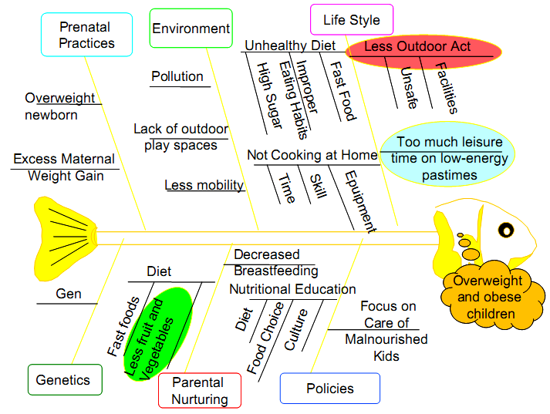
Figure 4.1: Fishbone diagram for cause of overweight and obese children

Accordingly, it is apparent from the group of benefit nos. 4 5 and 8 that teaching the children to participate in gardening, contributes to preventing and resolving some problems related to the children’s weight. Helping the children do all the physical activities rather than spending time on unhealthy activities and helping the children like and eat more vegetables are all the things that we should do to control the children’s weigh.
Watching television, playing games or using computers are considered as entertainment and leisure activities which do not consume a lot of energy. However, there are now many attractive video games and advertisements on fast-food and carbonated beverage attracting the children’s attention. These will make the children become lazier in doing exercise and physical activities. On the other hand, they provide more significant amount of calories for the children who eat and play or eat and watch television at the same time. Therefore, as gardening helps the children relax they will not spend much time on unhealthy entertainments. It is more apparent when it comes to the benefit of helping the children like eating vegetables more. Everybody, including both the adult and children, is always interested in treating raw materials and enjoying the meals made from their own produce when they do the gardening. While doing the gardening, the children will take on the tasks of: grubbing, seeding, fertilization, watering and pruning, which mean physical activities assisting the consumption of energy and practicing of immature muscles of the children.
In fact, the final purposes of losing weight for the children include: help the children consume more input energy by causing them to act rather than spending time on recreation activities which do not either require any energy consumption or provide any benefits; help the children reduce the amount of input energy by adding more vegetables as well as cellulose to their meals.

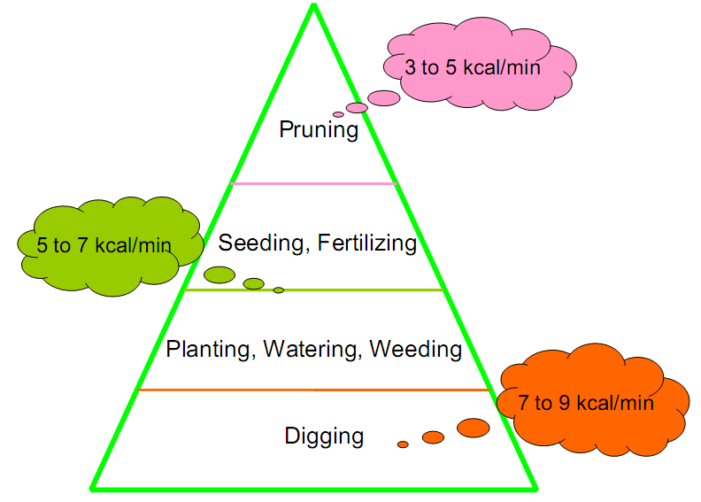
Figure 4.2: Energy consumed by activities taken during gardening

Subject to the weight of children, we will apply different types of physical activities/exercise at appropriate intensity levels to control their weight.
Ho Chi Minh City is known as the leading city of the whole nation with respect to the percentage of children smaller than 5 years old having over-weighted and obesity problems and this has been widely observed in the central districts of the city.
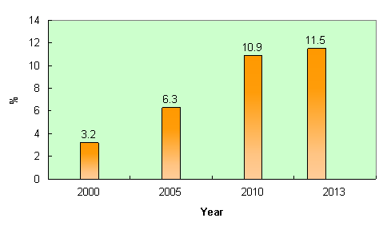
Figure 4.3: Percentage of over-weight and obese children smaller than 5 years old
in Ho Chi Minh City (Source: The Ho Chi Minh City Nutrition Centre)

I have made a survey on the percentage of over-weight and obese kindergarten children who live in Ho Chi Minh City and do gardening either at the kindergarten or at home. The survey shows a good result of 4.8% which is significantly less than the figures published by the Ho Chi Minh City Nutrition Centre in the recent years. This is clear evidence demonstrating the effectiveness of gardening activities.
5. Conclusions
For the young, overweight or obese children, strict diet is not recommended because it may slow down their development and adversely impact upon their health. Studies show that teaching the children to do gardening will not only bring about numerous benefits but also help resolve the problem of the children’s weight by encouraging them to do physical activities and exercise widely, causing them to like eating vegetables more instead of spending time on unhealthy recreation activities. This approach is a foundation for supplementing any further study in the future, on the resolution of over-weight and obesity of the children.

References
Obesity and Overweight, The World Health Organization, 2006.
General Nutrition Survey 2009 - 2010, Ministry of Health, Vietnam Medicine Publisher, 2010

Authors’ Biographical Notes

Nguyen Bich Ngoc¹ is a third-year student at Ho Chi Minh City University of Food Industry. She study Food Safety and Quality Assurance.

Ngo Van Nhon² is the chairman of Vietnam Quality Association of Ho Chi Minh City (VQAH) period 2011-2016, a director of Institute for Quality Assessment and Development (IQAD). He holds the Mechanical Engineer, MBA and Ed.PhD degrees. His research interests are in the areas of higher-education, quality management and public administration. He also won three Best Paper Awards in various past ANQ Congresses.
Duong Hoang Kiet³ is a lecture at Ho Chi Minh City University of Food Industry. He is a dean of ISO Department.

Nguyen Thi Thao Minh⁴ is a lecture at Ho Chi Minh City University of Food Industry. She is a Head of Food Safety & Quality Assurance.

